DURING APRIL 2023

150
PATIENTS DID NOT ATTEND A FACE TO FACE APPOINTMENT
If you are unable to attend always
cancel your appointment
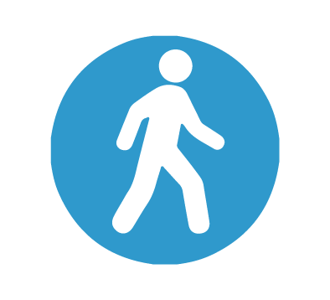
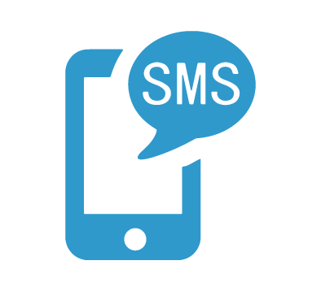
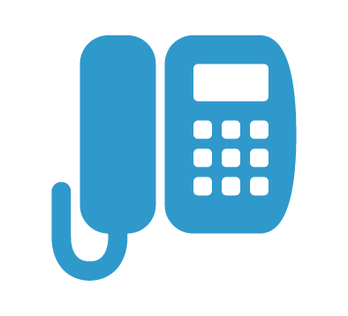
Visit the practice in person
Text back to your reminder message
Call us on 01942 483930

